Task Management Application

* **TABLE OF CONTENTS**

|  |
| --- |
| * **CONTENTS** |
| * ABOUT |
| * REQUIREMENTS |
| * UI DESIGN |
| * CLASSES & BEHAVIOURS |
| * UML Diagram |

# About:

The aim of this project is to develop an Android application that streamlines task management by allowing users to schedule tasks based on specific times throughout the day. At the designated time, a pop-up notification will appear prompting the user to either complete or postpone the task. The status of completed and postponed tasks will be accessible on the "View Task Status" page for easy tracking and monitoring.

# Requirements:

* 1. Updated Version of Visual Studio Professional 2022 IDE.
  2. .NET MAUI 7.0 or later.
  3. Android Version of 5.0(lollipop) or above.
  4. Fundamentals of C# Programming Language.
  5. Log4J library for logging.

# UI Design:

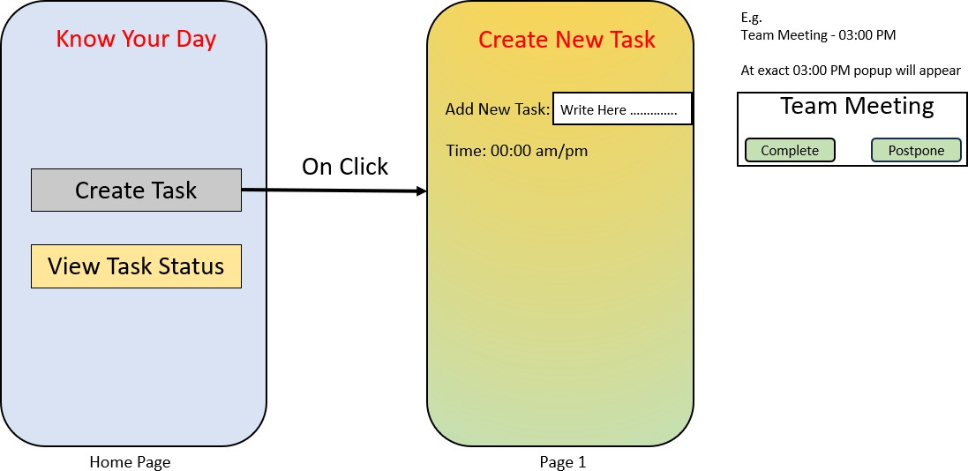

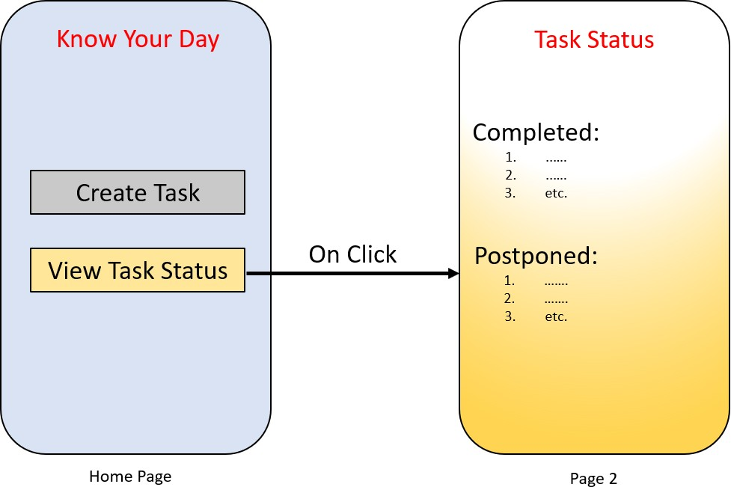

**Classes and Behaviors:**

* **MainPage:** Represents the Home Page of application. It provides navigation to other pages like **‘CreateTaskPage’** and **‘TaskStatusPage’**.
* **CreateTaskPage:** Allows users to create new tasks. It provides a form for users to input task details and handles the creation of tasks.
* **TaskStatusPage:** Displays the status of tasks. It also shows a list of tasks filtered by their status, including completed and postponed.
* **onCreateTaskClicked( ) method** is event handler for button ‘Create Task’, when button get pressed, user will navigated to Create task page where user can add tasks.
* **onViewTaskClicked( ) method** is providing event handler for button ‘View Task Status’, it will navigate to task status page where user can see completed and postponed tasked.

**UML(**Unified Modeling Language**) Diagram:**

